Braille Alphabet and Numbers

[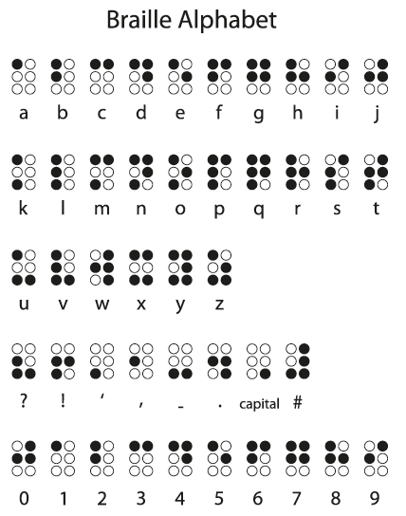](http://www.google.com.au/url?sa=i&rct=j&q=&esrc=s&source=images&cd=&cad=rja&uact=8&ved=0ahUKEwixgNrs-uDMAhWlMKYKHekuDEAQjRwIBw&url=http%3A%2F%2Fwww.todayifoundout.com%2Findex.php%2F2013%2F11%2Fhistory-braille%2F&bvm=bv.122129774,d.cGc&psig=AFQjCNHp1ob7XnlQgfnkSFp2I2m1yWueqQ&ust=1463569291112652)