Semaphore Code

[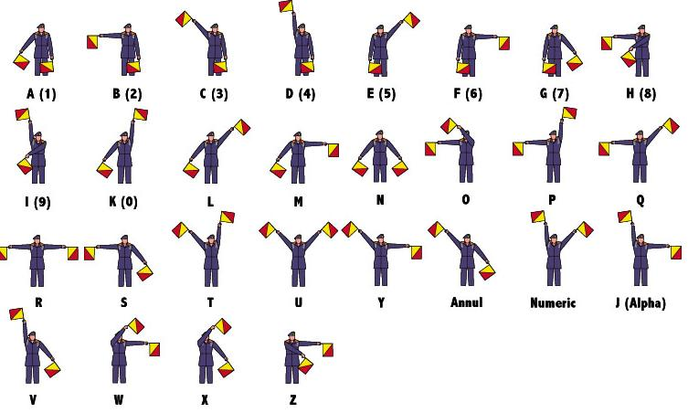](http://www.google.com.au/url?sa=i&rct=j&q=&esrc=s&source=images&cd=&cad=rja&uact=8&ved=0ahUKEwii5OGb-eDMAhVEYaYKHVBKAUIQjRwIBw&url=http%3A%2F%2Fthethousands.com.au%2Fmelbourne%2Fmake%2Fsemaphore-flags-sewing-and-waving&psig=AFQjCNEXU-RzMRoWDGOa4Io_zZBV_DW3gw&ust=1463568911930870)