**Playing with the features in Word**

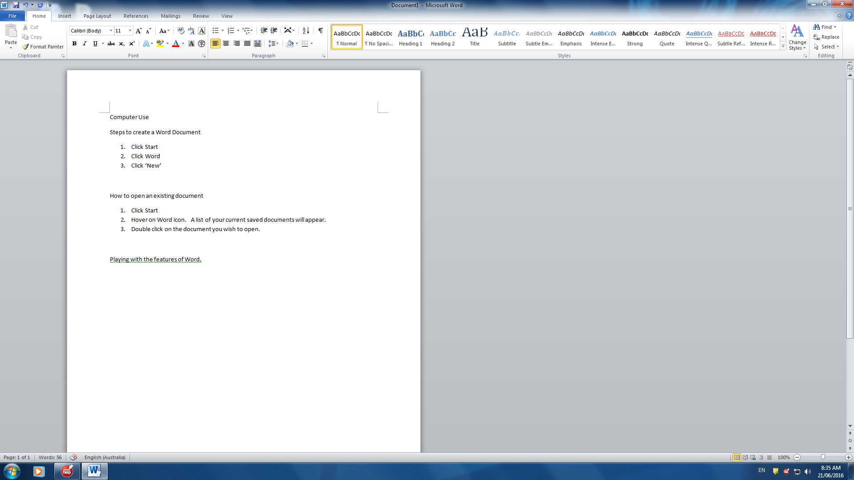

**What you use the most**

**Highlighting**

**To change something about a word or sentences easily, just highlight the section you want changed and make the changes. Eg**

1. **Put curser at the start of the section.**

**Paragraph Section**

Using dot points

* Put curser on the line where the dot points will start.
* Click the dot point button in the paragraph section.
* When finished with dot points, click ‘enter’ and
* Then click the ‘dot point’ button again.

1. You can do the same thing to number your ideas instead of dot points.
2. Just click on the ‘number points’ button.
3. **Left click and hold, then drag across to the point where you want to stop.**

**Font Section**

Font Colour

1. Highlight section
2. Click on dropdown arrow
3. Choose colour

**Bold***, Italics*, Underline

1. Highlight
2. Click on the ‘**B’**, ‘*I’*, U

**HOME TAB**

**Saving to USB**

. Click on **file** tab

. Click on **Save As**

**.** Double click on **Computer**

**.** Find your USB under **Removable storage.**

**.** Name your file

**.** Click **Save**

*To change font*

1. Highlight the section or word that you

want to change

1. Click on the arrow in the drop down box.
2. Click your choice
3. Save the work.

**To change letter size**

1. Highlight section
2. Click on the drop down arrow
3. Choose the size

**INSERT TAB**

* Click on Work Art Symbol.
* Choose the type of word art you want to use.
* Right click on the one you want. The Word Art box will appear on your word document.
* Right click on box and drag to where you want it.
* Type the words you want to use.

***Clip Art***

**Word Art**

Click on ‘Clip Art’

Click on the ‘Search for bar’ on the right. Curser will appear.

Type in a description of the picture you want to use(Eg cats) and press Enter.

Scroll through the pictures until you find the one you want.

C:\Program Files\Microsoft Office\Media\CntCD1\ClipArt1\j0185776.wmf

**TEXT BOX**

* Click on text box symbol
* Click on ‘draw text box’ choice.
* Move curser to your word document
* Hold the left side of the mouse down and draw your text box.
* You can now type inside the box.

Right click on the picture and it will appear in your word document where the curser is.

**PAGE LAYOUT TAB**

***Margins* – The space from the edge of the page to where the typing starts.**

* **Click on ‘Margins’ icon**
* **Choose between ‘Normal’ or ‘Narrow’ for your margin size.**
* **Click on the one you want to use for your document.**

**Page Borders-** an edge around the page.

Click on ‘Page Border’ icon

Click on the type of border that you want to use.

Choose a thickness for your border.

Choose your colour, thickness and Art.

Click OK

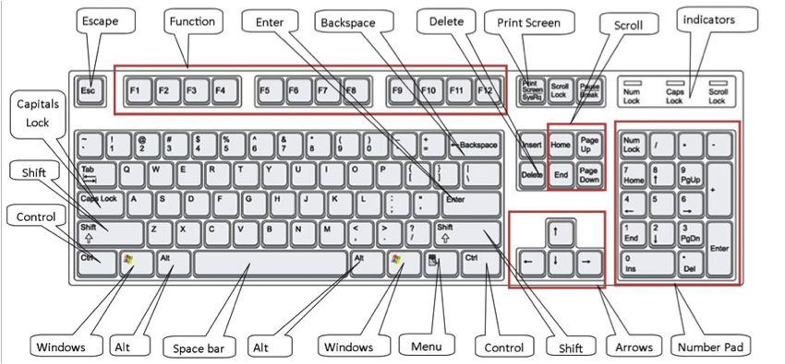

Keyboard

**Back arrow**: move the cursor backwards or delete.

**Space Bar**: move your cursor forward one space at a time.

**Shift:** Hold shift to make your CAPITAL letters or use the symbols on the number keys.

**Arrows**: moves your cursor in each direction.

**Print Screen**: On the top row of the keyboard. When you push this button you will make a copy of everything that is on the computer screen at the time.

**CAPS Lock**: This will make everything Capital



Microsoft Word



Task

For this task, you need to create a word document and use the skills you have learnt.

*You* ***MUST include***

1. Your name, teacher’s name
2. A little bit about yourself
3. Your favourite animal
4. Your favourite thing to do at school.

*Some of your document* ***MUST***

* Be centred
* Use dot points or numbers

*Your document* ***MUST*** *have:*

* A border
* Information in different font sizes
* Information in different font colours
* At least one (1) text box
* At least one (1) image from clip art.